Planning a Funeral / Memorial Service

While we feel alone during a time of death and dying, we are always surrounded by the love of God made known to us in Jesus Christ and Christ’s body here on earth, the people of God. God’s peace be with you during time of blessing and times of grief.

A number of choices will need to be made beyond that of burial, cremation, and organ donation before the service can be planned. They include:

-Will the body be buried, cremated or donated?

-Does the deceased have a burial plot? If not, a funeral director, or the Roxbury Cemetery Sexton, can assist you with the purchase of a grave.

-Will the service be a funeral or memorial service? Funeral services have the casket or urn present in the service; memorial services take place after burial or cremation.

-Will the burial, scattering or inurnment be a continuation of the worship service or take place before or at an extended time after the service?

-Will there be a reception following the worship or committal service, and where will it be held

The funeral or memorial service is ordinarily held in the church, or the funeral home. This space is familiar, designed for worship and is rich with the symbols of our faith. It may be held on any day of the week, and should be planned for a time that will meet not only the needs of the family, but also enable the participation of other members of the church family and wider community. In place of a church or funeral home service, an extended Graveside Service can be held.

Basic Funeral / Memorial Service Outline
Prelude Music
Words of Welcome – announce reception location
Call to Worship
*Hymn
Prayer of Invocation ending with Lord’s Prayer (trespasses)
Scripture Readings
Solo
A Time of Remembrance
Brief Meditation by Minister
Prayer
*Hymn (optional
*Words of Commendation
Benediction
Recessional
(Burial)
Reception

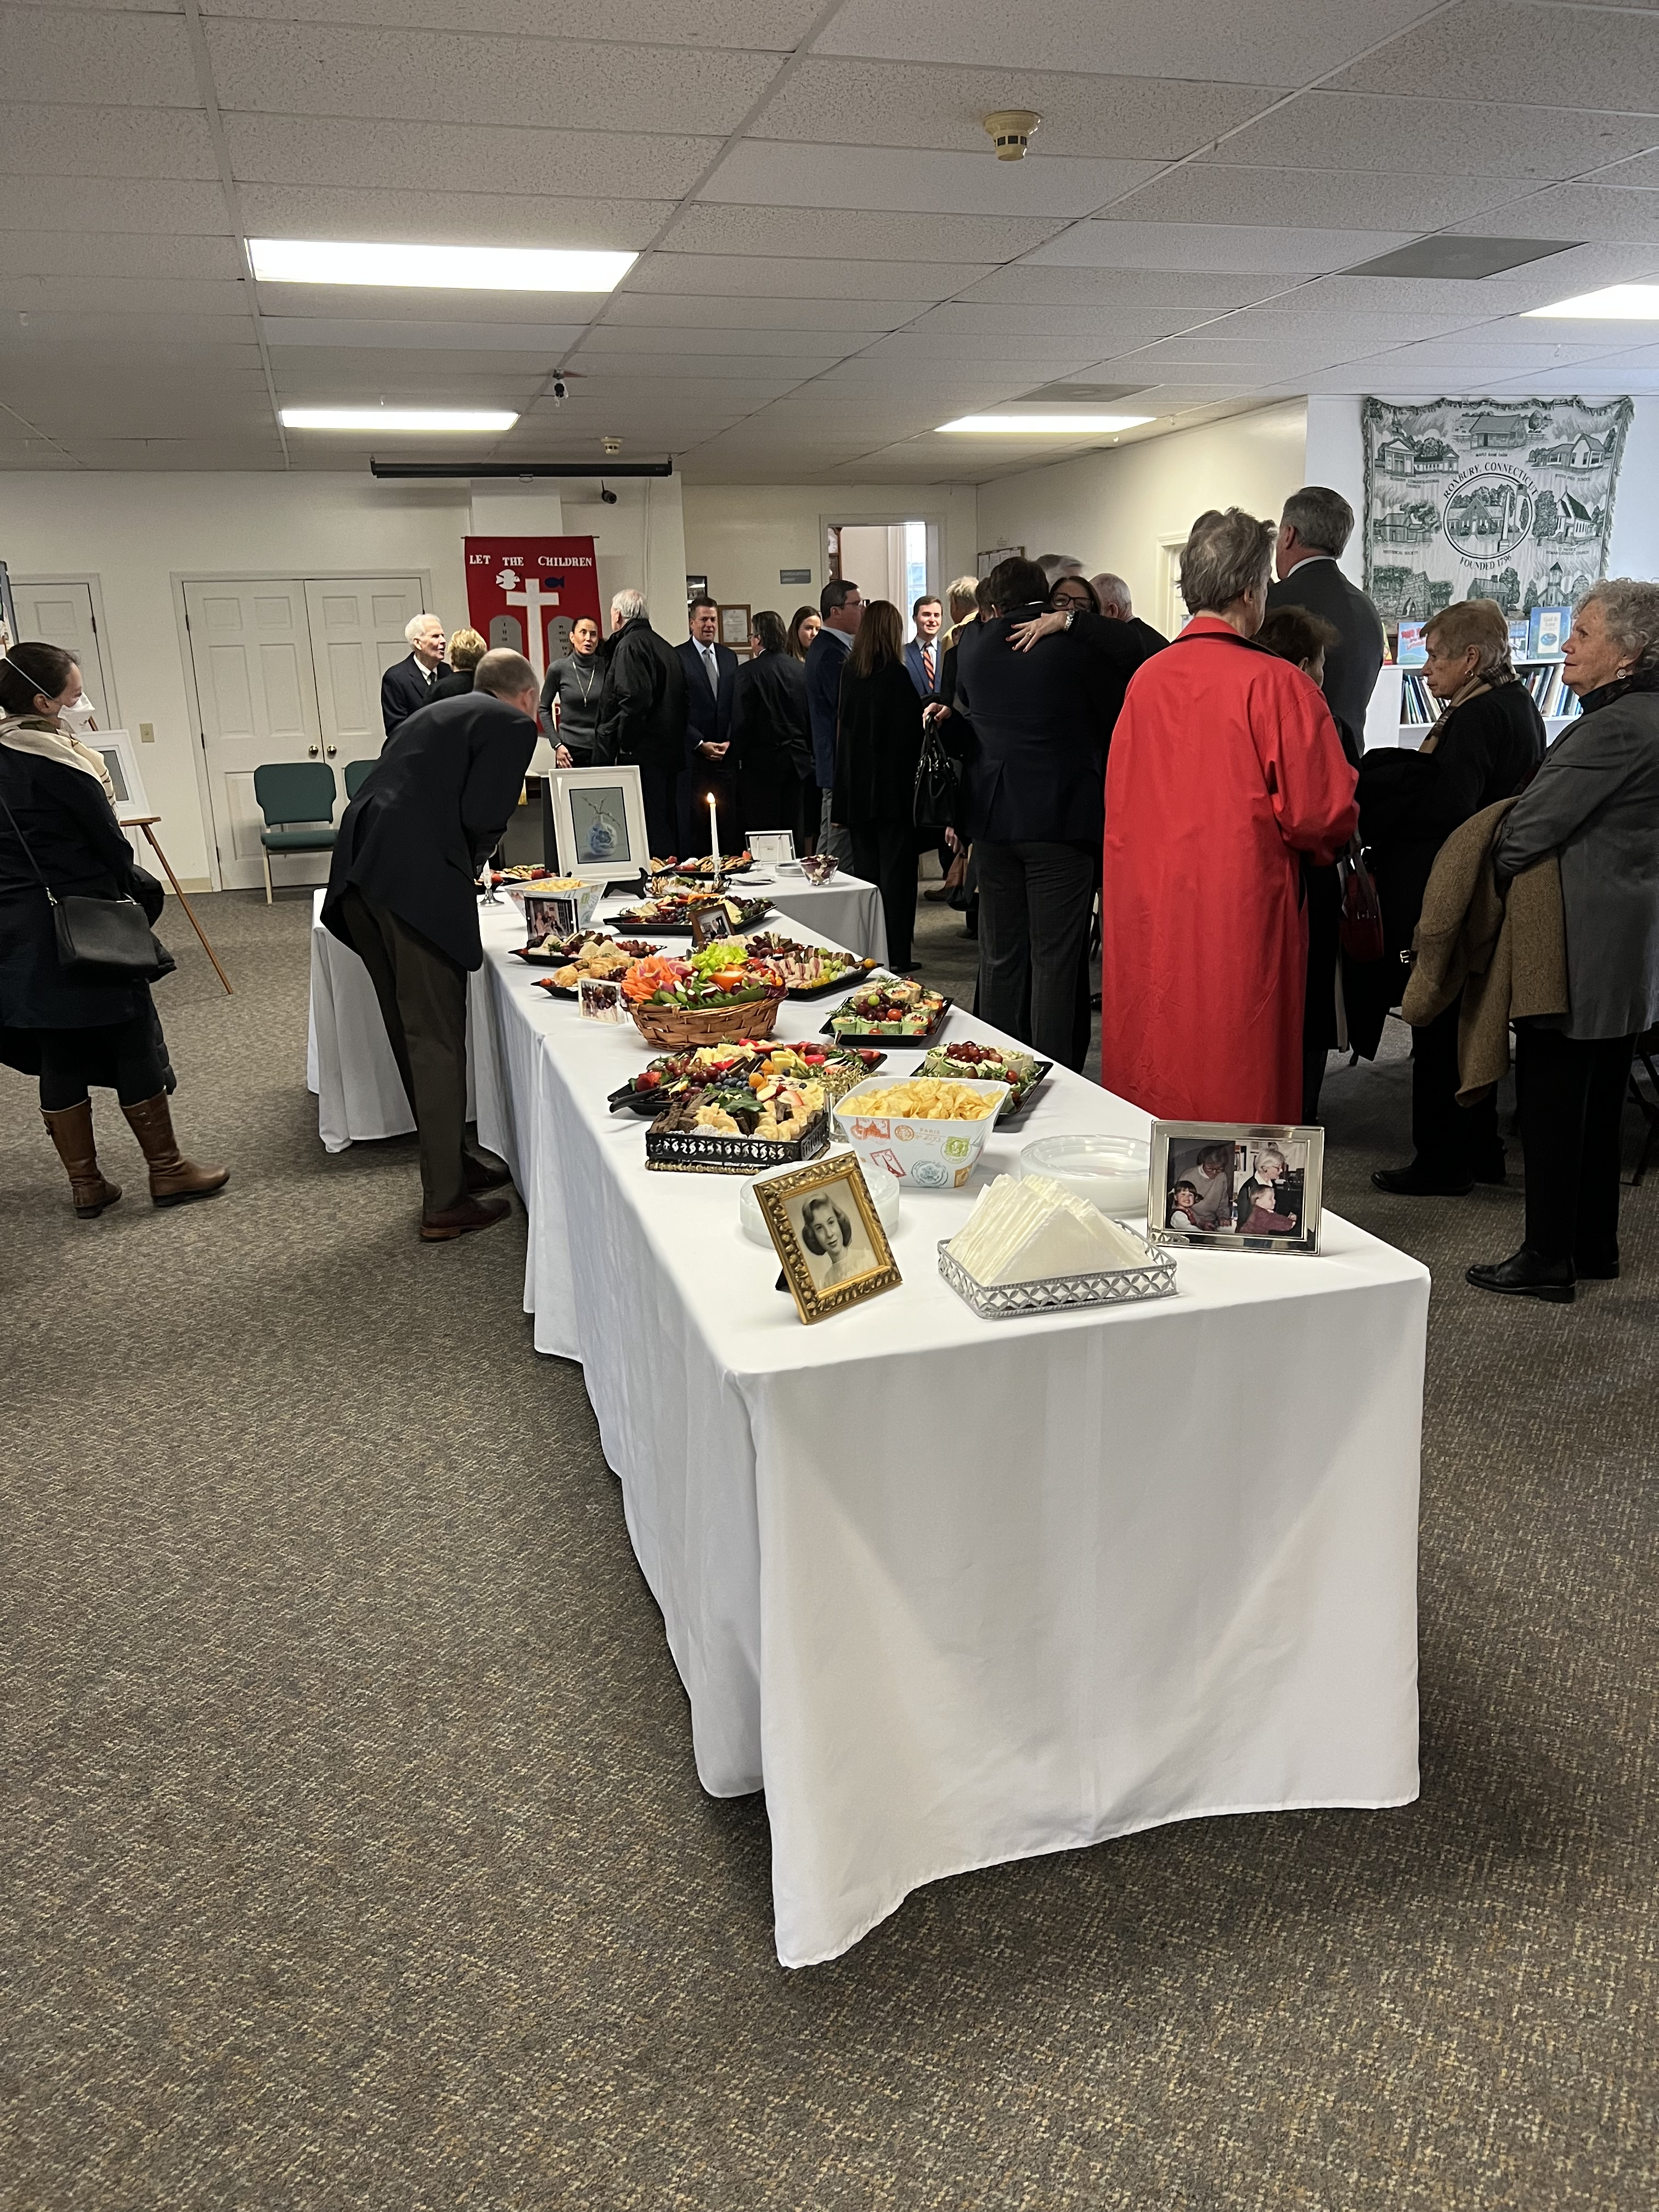

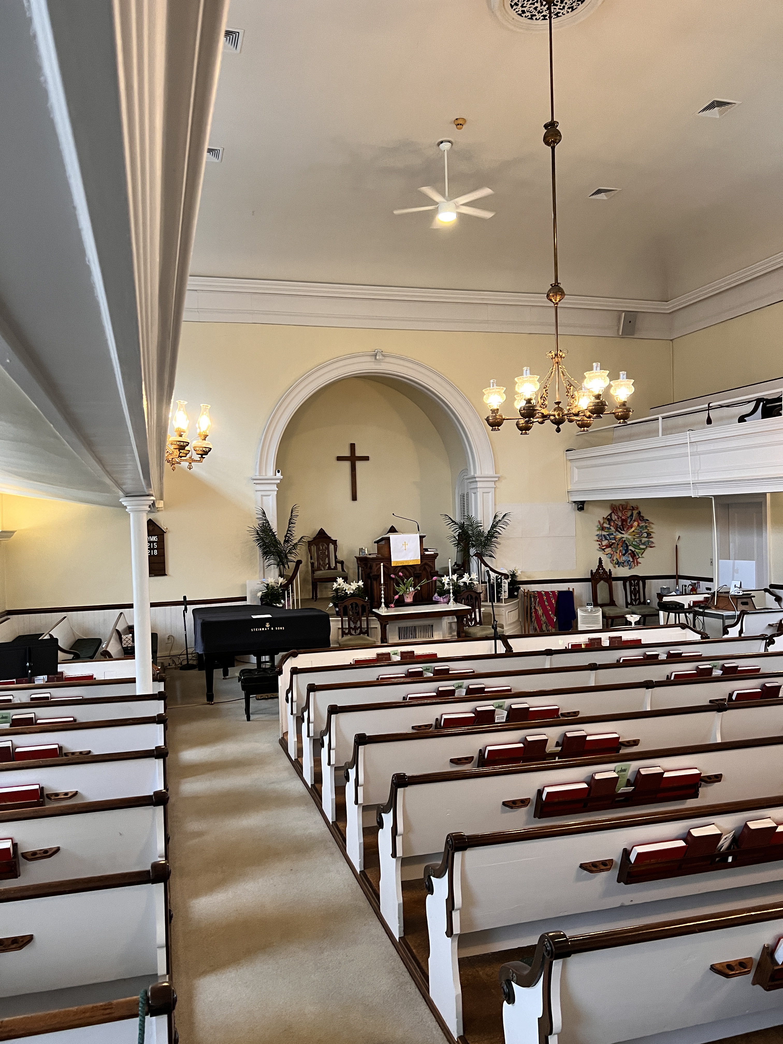
Church Fees
Meetinghouse (Sanctuary)
Financial supporting members: $0
Others: $200
Clergy: $300
Organist: (no outside organists) $200
Fellowship Hall for reception: $200 for space only

Receptions in Hall: It is expected that the family will provide the food and refreshments for a reception as well as clean-up of the Kitchen and hall afterwards. We can give you a list of caterers if needed. We have a reception committee who will provide coffee, tea, and punch, and set out the food brought in. June 2023
ROXBURY CONGREGATIONAL CHURCH
A Congregation in the United Church of Christ

24 Church Street, Roxbury, Connecticut 06783
860-355-1978 info@roxburychurch.org www.roxburychurch.org

The Reverend David F. Peters, Minister
david@roxburychurch.org
Sandra Kleisner, Minister of Music
sandy@roxburychurch.org

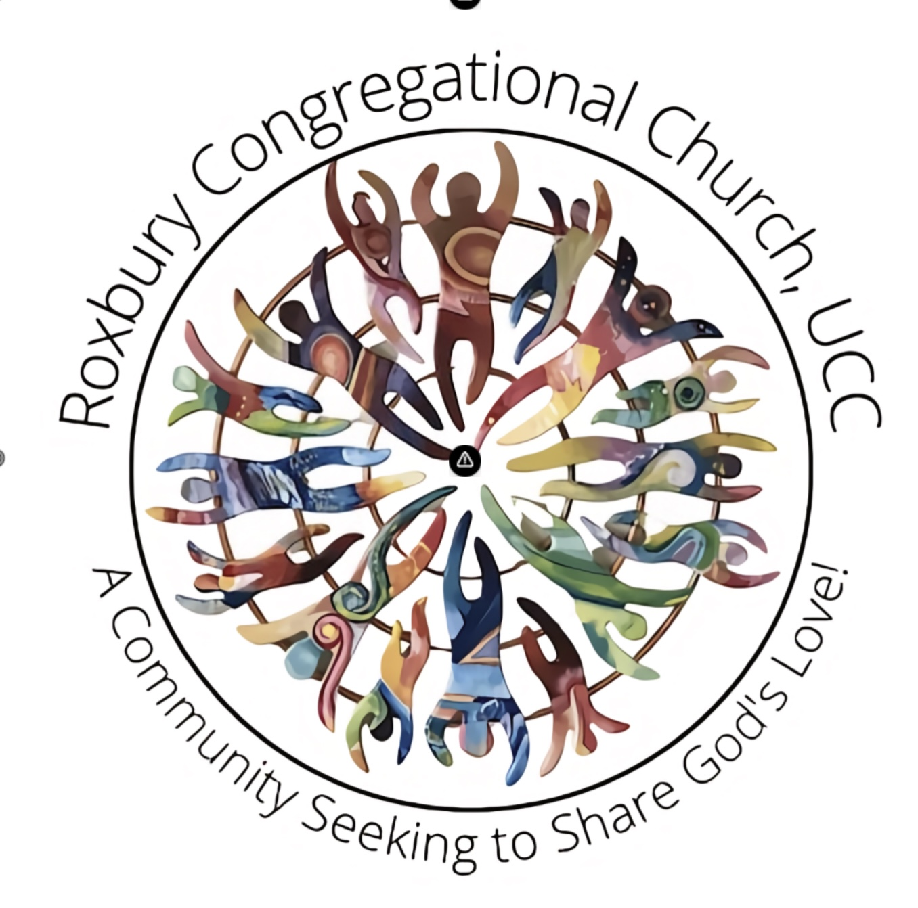

A Guide for Funeral and Memorial Services

You may be reading this Guide because you have recently had a loved one pass away or are considering the options for you or others at the time of dying.

Please know that the Roxbury Church stands with you in love, support and guidance during these times. Our Minister and members of the congregation consider it a privilege to be present with you.

We hope that this guide might answer some of the questions you may have as well as offer some options to consider. Please feel free to contact our Minister at the Church Office for more information.

